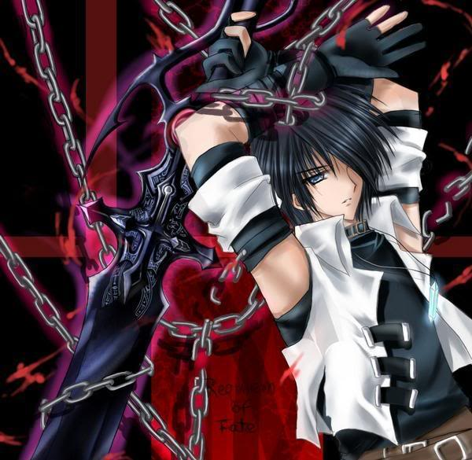Shikamaru Kazishi Lvl:3 Hp:36 AC:16 Init:+2

Str: 13

Dex: 15 ShadowSword: +3 to hit Dmg: 1d8+1

Con: 14

Int: 18 Mana: 20 Rite of Chi: 3/Day

Wis: 14 Fort: +0

Cha: 8 Ref: +3

Skills: Will: +4

-Shadow Casting +6

-Shadow Mastery +6

-Endurance +6

-Perception +6

-Stealth +6

-Martial arts +6

---Defenses 4

---Sneak attack +1d6

-Survival +6

-Trap Craft +6

-Theviery +6

Gear:

* Fusillade of Darts (x3) 500gp: Location Trap; Atk +10 ranged (1d4+1, dart); multiple targets (fires 1d4 darts at each target in two adjacent 5-ft. squares); [Search](http://www.d20srd.org/srd/skills/search.htm) DC 14; [Disable Device](http://www.d20srd.org/srd/skills/disableDevice.htm) DC 20
* Tripping Chain (x1) 1,267gp: Location Trap; Atk +15 melee touch ([trip](http://www.d20srd.org/srd/combat/specialAttacks.htm#trip)), Atk +15 melee (2d4+2, spiked chain); [Search](http://www.d20srd.org/srd/skills/search.htm) DC 15; [Disable Device](http://www.d20srd.org/srd/skills/disableDevice.htm) DC 18
* Cloak Of Resistance 1,000gp: +1 to all saves
* 200gp extra

Disadvantages:

* Hunted: Akatsuki
* Obligations: Team Comes First
* Late to the Party

CP POINT BUY 130CP

3D10 18cp

+4ref, +3will 21cp

+2Bab 12cp

Skills 6cp(+6cp from fast learner)

Evasion 6cp

Harnessed Intellect 6cp

Skill Emphasis (perception) 3cp

Skill Emphasis (shadow casting) 3cp

Skill Focus (+2) (perception) 4cp

Adept (Shadow Casting & Mastery, Perception, Craft (Traps)) 6cp

Fast Learner (skills) 6cp

Spirit Weapon (ShadowSword / longsword) 6cp

Mana(rune casting) 4d6 12cp

Rite of Chi 6cp

-x4 Bonus Uses 6cp

Proficiency (Longsword/simple weapons) 6cp

Relic (+2 Int & Deep Sleep) 3cp

Shadow Binding Rulling’s (Lvl 1 Power)

*Hold Lasts 2+(1/2Caster Level) rounds.

*Can Chain Base Range (30ft) extra times up to (+1/2 caster level).

*Will Save to avoid capture, Then Str Check to get out.

-Depending on the Situation, The Will or the Str check may get Stronger, or Weaker.